

PUPPET INSTALLATION
DevOps Certification Training

support@intellipaat.com
+91-7022374614
US: 1-800-216-8930(Toll Free)

PUPPET INSTALLATION ON UBUNTU
Installing Puppet Master

Step 1: Run the following commands for installing Puppet Master
$ sudo apt-get update
$ sudo apt-get install wget
$ wget https://apt.puppetlabs.com/puppet-release-bionic.deb
$ sudo dpkg -i puppet-release-bionic.deb
$ sudo apt-get update
$ apt policy puppet master
$ sudo apt-get install puppet-master

Installing Puppet Agent
Step 2: Run the following commands for installing Puppet Agent
$ sudo apt-get update
$ sudo apt-get install wget
$ wget https://apt.puppetlabs.com/puppet-release-bionic.deb
$ sudo dpkg -i puppet-release-bionic.deb
$ sudo apt-get update
$ apt policy puppet master
$ sudo apt-get install puppet

Configuring Puppet Master
Step 1: Add the following lines in the puppet-master configuration file
$ sudo nano /etc/default/puppet-master
JAVA_ARGS="-Xms512m Xmx512m" //Add this Line
$ sudo systemctl restart puppet-master

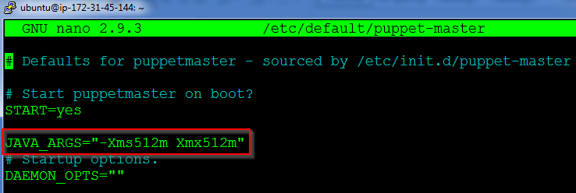
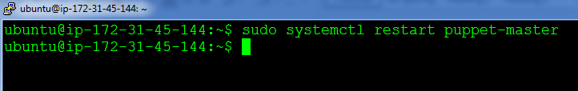

Step 2: Next open port 8140 on the Puppet Master’s firewall
$ sudo ufw allow 8140/tcp

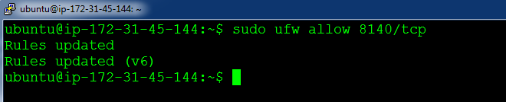

Step 3: Make changes to the hosts file which exists in /etc/hosts. And add the Puppet Master IP address along with the name “puppet”
$ sudo nano /etc/hosts

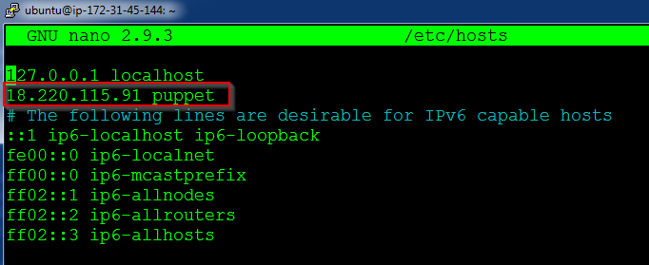

Step 4: Create the following directory path:
$ sudo mkdir -p /etc/puppet/code/environments/production/manifests

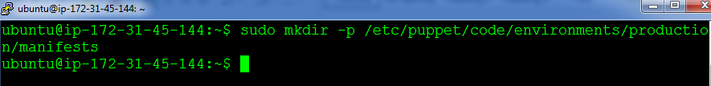

Configuring Puppet Slave

Step 1: Add the entry for Puppet Master in /etc/hosts
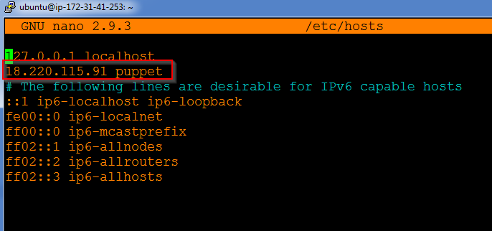

Step 2: Finally start the Puppet agent by using the following command. Also, enable the service, so that it starts when the computer starts
$ sudo systemctl start puppet
$ sudo systemctl enable puppet

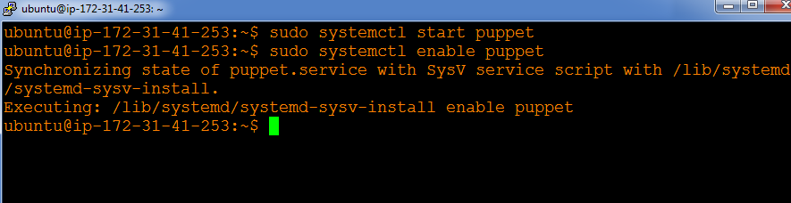

On Master

Step 1: Type the following command,
$ sudo puppet cert list

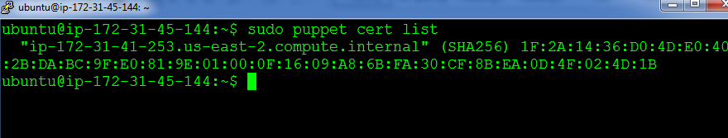

Step 2: Finally, sign the listed certificate using the following command:
$ sudo puppet cert sign --all

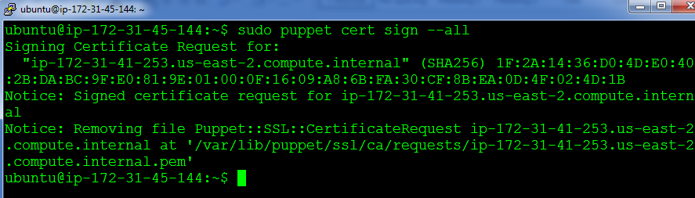

You are now ready to use the Puppet cluster!

